Kennesaw State University

CS Department

CS 4306, Algorithm Analysis, Section 3

Samples of Sorting Algorithm with analysis

Final Report

April 14, 2017

Enrique Penaloza

**I. Introduction**

Sorting is the process of rearranging a sequence of objects to put them in a type of logical order (online book). Sorting in computing is significant in many different ways because it forms the spine of computational problem solving to complex search engine algorithms, such as “google.com” or sorting students into alphabetical order or by student ID.

For every problem, the challenge faced is that a constant single algorithm cannot cover all of the factors the algorithm needs to be efficient. The factors the algorithm needs attention on are; certification, efficiency and memory usage.

Certification implies that whether the sort implementation always puts the array in order, no matter what the initial order. When we use code, that sores values into the array directly, we do not have full assurance.

Sorting algorithm’s rate on efficiency can be measured by time analysis, which consists of reasoning about an algorithm’s performance. We start by providing facts about the number of basic operations (compares and exchanges, or perhaps the number of times the array is accessed, for read or write) that the various sorting algorithms perform for various natural input models (Sedgewich). We express our formulas for the operations in terms of *n* in the kind of information in a format called big-O notation (Main). If the largest term in a formula is no more than a constant times n^2, then the algorithm is said to be “big-O of n^2”, written O(n^2) and the algorithm is called quadratic. If the largest term in a formula is no more than a constant times n, then the algorithm is said to be “big-O of n”, written O(n) and the algorithm is called linear. If the largest term in a formula is no more than a constant times a logarithm of n, then the algorithm is said to be “big-O of the logarithm of n”, written O(log n) and the algorithm is called logarithmic (Main). During a time analysis, you find yourself unable to provide an exact count of the number of operations. The best practice is to always consider the worst-case analysis, always guaranteed to be always less than the estimate that you use in the analysis. Other two kinds of time analysis are average-case and best-case. Average case determines the average number of operations required for a given *n* and best-case analysis determines the fewest number of operations required for a given *n*.

Memory usage is also a factor because the amount of extra memory used by a sorting algorithm is often as important as its running time. Sorting algorithms are divided into two basic types: those that sort in place and use no extra memory except for a small function-call stack or a constant number of instance variables, and those that need enough extra memory to hold another copy of array to be sorted.

This paper is organized as followed. Section II through section VI will define the sorting algorithm’s Insertion Sort, Merge sort, Quick sort, Bubble sort, and Bucket sort respectfully followed by including the algorithm’s function process and analysis. Conducting an analysis on the algorithm will consist of its certification, running time, and extra memory requirement. Section VII will conduct an interview question in the book to illustrate the computer science fundamentals acknowledging sorting algorithms. Section VIII will conduct a conclusion on why this was the chosen topic and new information illustrating new finding over sorting algorithms. Last, section IX will list the references used on this paper.

**II. Insertion Sort**

Insertion sort iterates through all of the data after every pass thorough the algorithm only to traverse the data it needs to until the segment that is being sorted is sorted.

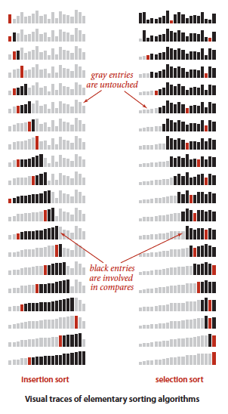

This following array will be called data. The first component, data[0], is shaded to indicate that part of the array is sorted – even at the start of the array. Each iteration increases the size of the sorted side and decreases the unsorted side until the entire array is sorted (Main). The following pseudocode describes the whole process:

**for(i =1; i< c; ++i) {**

**Insert data[i] into the elements before data[i]**

**(which are already sorted) }**

The insertion of data[i] can be done in three steps, which we’ll illustrate when i is 3 for the sample array:

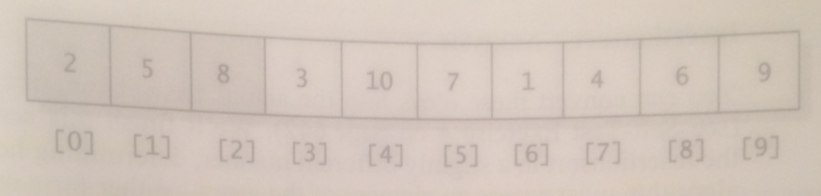

(Main)

Step 1: Save a copy of the number to be inserted. This step copies data[3] into a temporary local variable, shown underneath:

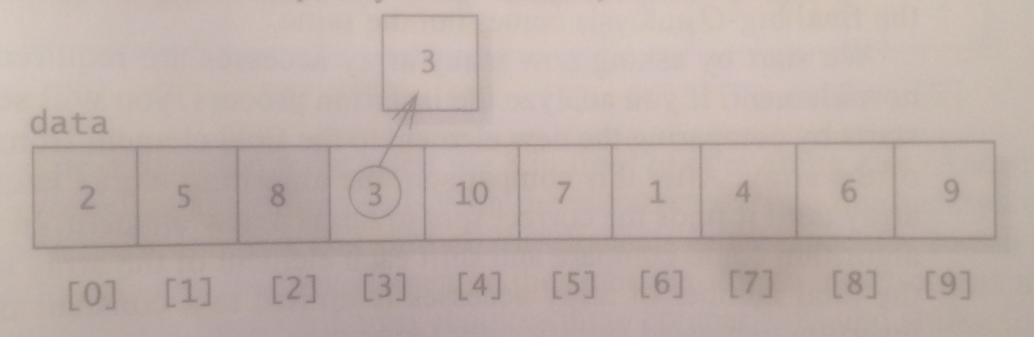

(Main)

Step 2: Move up the element before data[i] until you reach the stop to insert the new number. In the diagram below, we move the 8 and then 5 to introduce the correct order for data[i] (element 3).

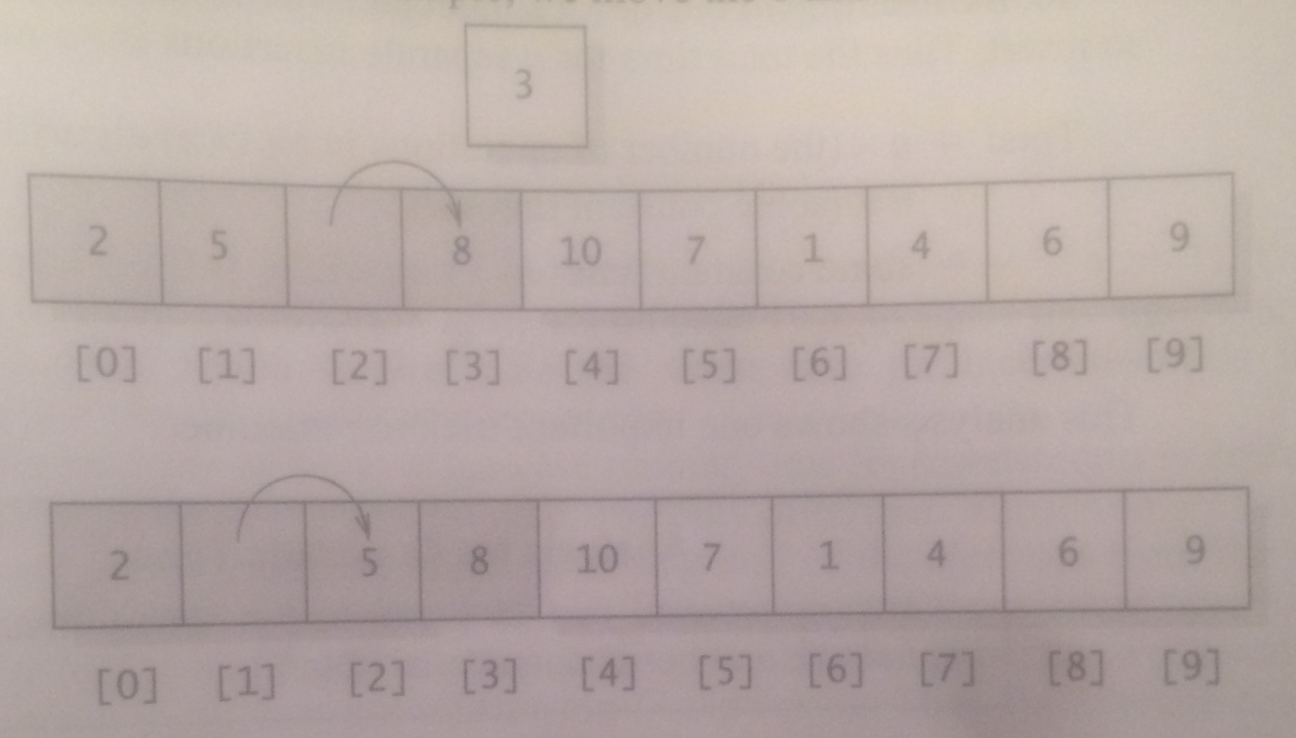

(Main)

Step 3: Insert the new number into the open spot. Diagram below illustrates the 3 inserted at its respected place (Main).

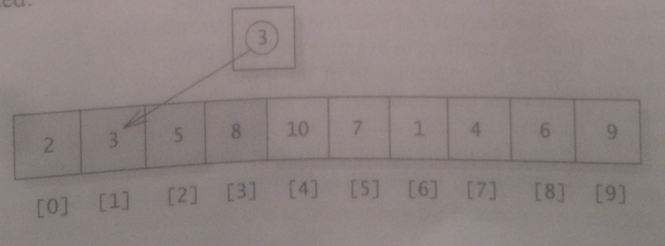

(Main)

There’s no record of ‘who’ invented insertion sort due to the algorithm was well known long before there were any computers capable of implementing the theory.

Analyzing the insertion sort is determined on how many times the algorithm must access an element of the array- either accessing the array for a comparison or for a swap of elements in the array. The count of array accesses is proportional to the total number of operations. This results to the insertion of one new element takes O(n) time and there are n elements to insert the total time for n separate insertions is O(n^2) making insertion sort categorized as a quadratic sorting algorithm. However, if the array is already sorted and you need to insert a new variable (best case), then the algorithm is linear (O(n)). The single-element examination is carried out once to insert each new element.

The running time of insertion sort depends on the initial order of the items in the array. If the array is large and its elements are already in order (or nearly in order), then insertion sort is much faster than if the entries are randomly ordered or worse ordered reverse. The function starts by comparing the new element to the final element from the sorted portion of the array (Main). After this comparison, the algorithm works backwards through the array until it finds the correct spot to insert a new element.

In a computer implementation, we need to make space to insert the current item by moving larger items one position to the right, before inserting the current item into the vacated position.

**III. Merge Sort**

Merge sort is an algorithm that divides the array near its midpoint, sorts the two half-arrays by recursive calls to the algorithm, and then merges the two halves to get a new sorted array of elements. Recursive calls are behind the divide and conquer technique design. The divide-and-conquer technique is when the problem is large, divide the problem into two smaller sub problems, each of which is about half of the original problem. We stop the recursive call by indicating a base case in which Merge Sort is when the array has only one element to try to halve too. The following diagram illustrates a Top-down mergesort algorithm.

After the array has recursively called the large array into sub arrays, the algorithm then begins to sorts the beginning elements of the first and second subarrays. Once sorting all of their elements, the final product of the two sub arrays is one new sorted merge array. This will continue until all of the first subarrays have been sorted and all of the second subarrays have been sorted too. One final sorting function concludes the first and second subarrays into the final sorted array.

The advantage of merge sort is the guarantee to sort any array of N items in time proportional to N log N. At each level of the pattern, the total work done by merging is O(n). So the total cost of merge sort is given by this formula:

(some constant) * n * (the number of levels in the pattern)

That number of “halving” is approximated by log2n (the base 2 logarithm of n). So the total cost of time for merge sort is O(n log n). Merge sort shares a running time of O(n log n) operations that is equivalent to its worst-case, best-case, and average case, which is still faster than the O(n^2) running times for the insertion sort algorithms.

The prime disadvantage is that it uses extra space proportional to n (the number of halving). During a merge sort, our merge function will be called repeatedly. Each call to merge allocates a temporary dynamic array, uses the array, and then releases the array. This repeated allocation and releasing of dynamic memory takes a significant amount of execution time.

**IV. Quick Sort**

C.A.R. Hoare invented Quicksort in 1960, and it has been refined since that time (Sedgewich). Quick Sort is also classified as a recursive-sorting algorithm using the divide-and-conquer method. Quicksort works by partitioning an array into two subarrays, then sorting the subarrays independently. Quicksort will decide on a particular value that belongs in the middle of the array, or at least approximate middle of the array. This is indicated as the pivot element or simply pivot. Most programming code use the last element in the array as their pivot of choice (Khreisat). Partioning will move all the values that are less than or equal to this pivot element toward the beginning of the array, that is, toward position with lower-numbered indices. All values that are greater than this pivot element are moved the other way, toward the tail end of the array, with higher-numbered indices (Main).

For the following example, we have array called A. It has the following elements: 3, 8, 7, 11, 2, 5, 4, and 6 respectfully. The pivot will be the last element of the array, 6. There are two placeholders that will help the array determine the current index it is partitioning through, c for current index, and an index to indicate which values are lower or higher than the value of the pivot, i for index. We start at A[0]. If the current index is lower than the pivot, we swap the current index element with the index element and we increment index element by 1. Now index is at A[1] and we start again where we left off two based on the current index. Element 8 is bigger than the pivot (6) so we increment the current index by 1, and again element 7 is bigger than the pivot so we increment the current index by 1 again, and again element 11 is bigger than the pivot so we increment the current index by 1. The following element is 2. Two is lower than the pivot so we swap the current element, 2, with the index element 8 and we increment the index placeholder by 1. When the current index reaches the pivot, it concludes that all of the elements before the index placeholder are lower than the pivot, while the elements after the index placeholder are larger than the pivot (Sedgewich). We swap the pivot and the element of where the index placeholder is on and the recursive process starts by using sub arrays to finish the process of quick sorting.

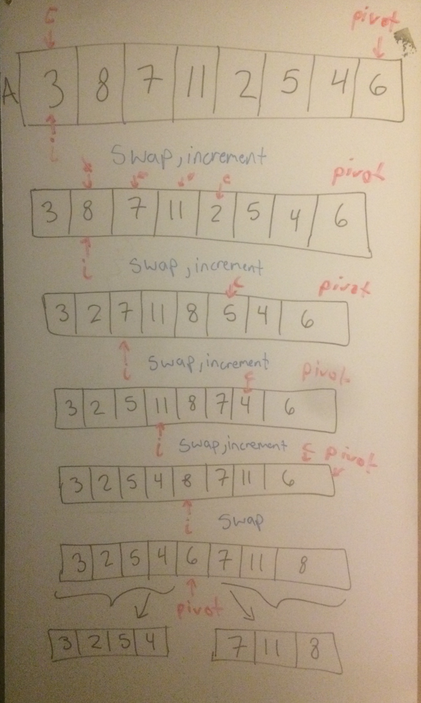

Once the pivot has been initially established in between the array, the array is broken into two sub arrays away from the pivot. The first sub array is all the elements that are lower than the value of the pivot (not sorted yet). We use recursion and indicate that 4 will be the new pivot for the sub array and place the two placeholder, c and i, to A[0]. Again if the current element is bigger than the pivot, we swap the current index element and the index. Fast-forward and we have the index placeholder at 5 and current index at 5. Because 5 is bigger than the pivot we only move the current index by 1 and because the current index is where the pivot is, we swap the pivot based on where the index placeholder is at so it results to 4 switching with 5. Recursively we do this again with subarray A[3, 2, 4] and another subarray of A[3, 2] which that array returns A[2,3] and the whole left sub array returns A[2, 3, 4, 5]. Figure below is an illustration of the process the sub array is sorted before the pivot.



Once the left sub array is returned, the right sub array of the pivot is sorted using the same procedures. The right sub array is A[7, 11, 8] with the current index and index placeholders located where element 7 is placed while the new pivot for the sub array is 8. Due to 7 being lower than 8, we swap 7 by itself and increment current index and index by 1. Because 11 is greater than 8, we increment only the current index which lands on the location of the pivot. The pivot and the index placeholder swap and the right sub array is sorted at this point. The right sub array returns A[7,8,11].

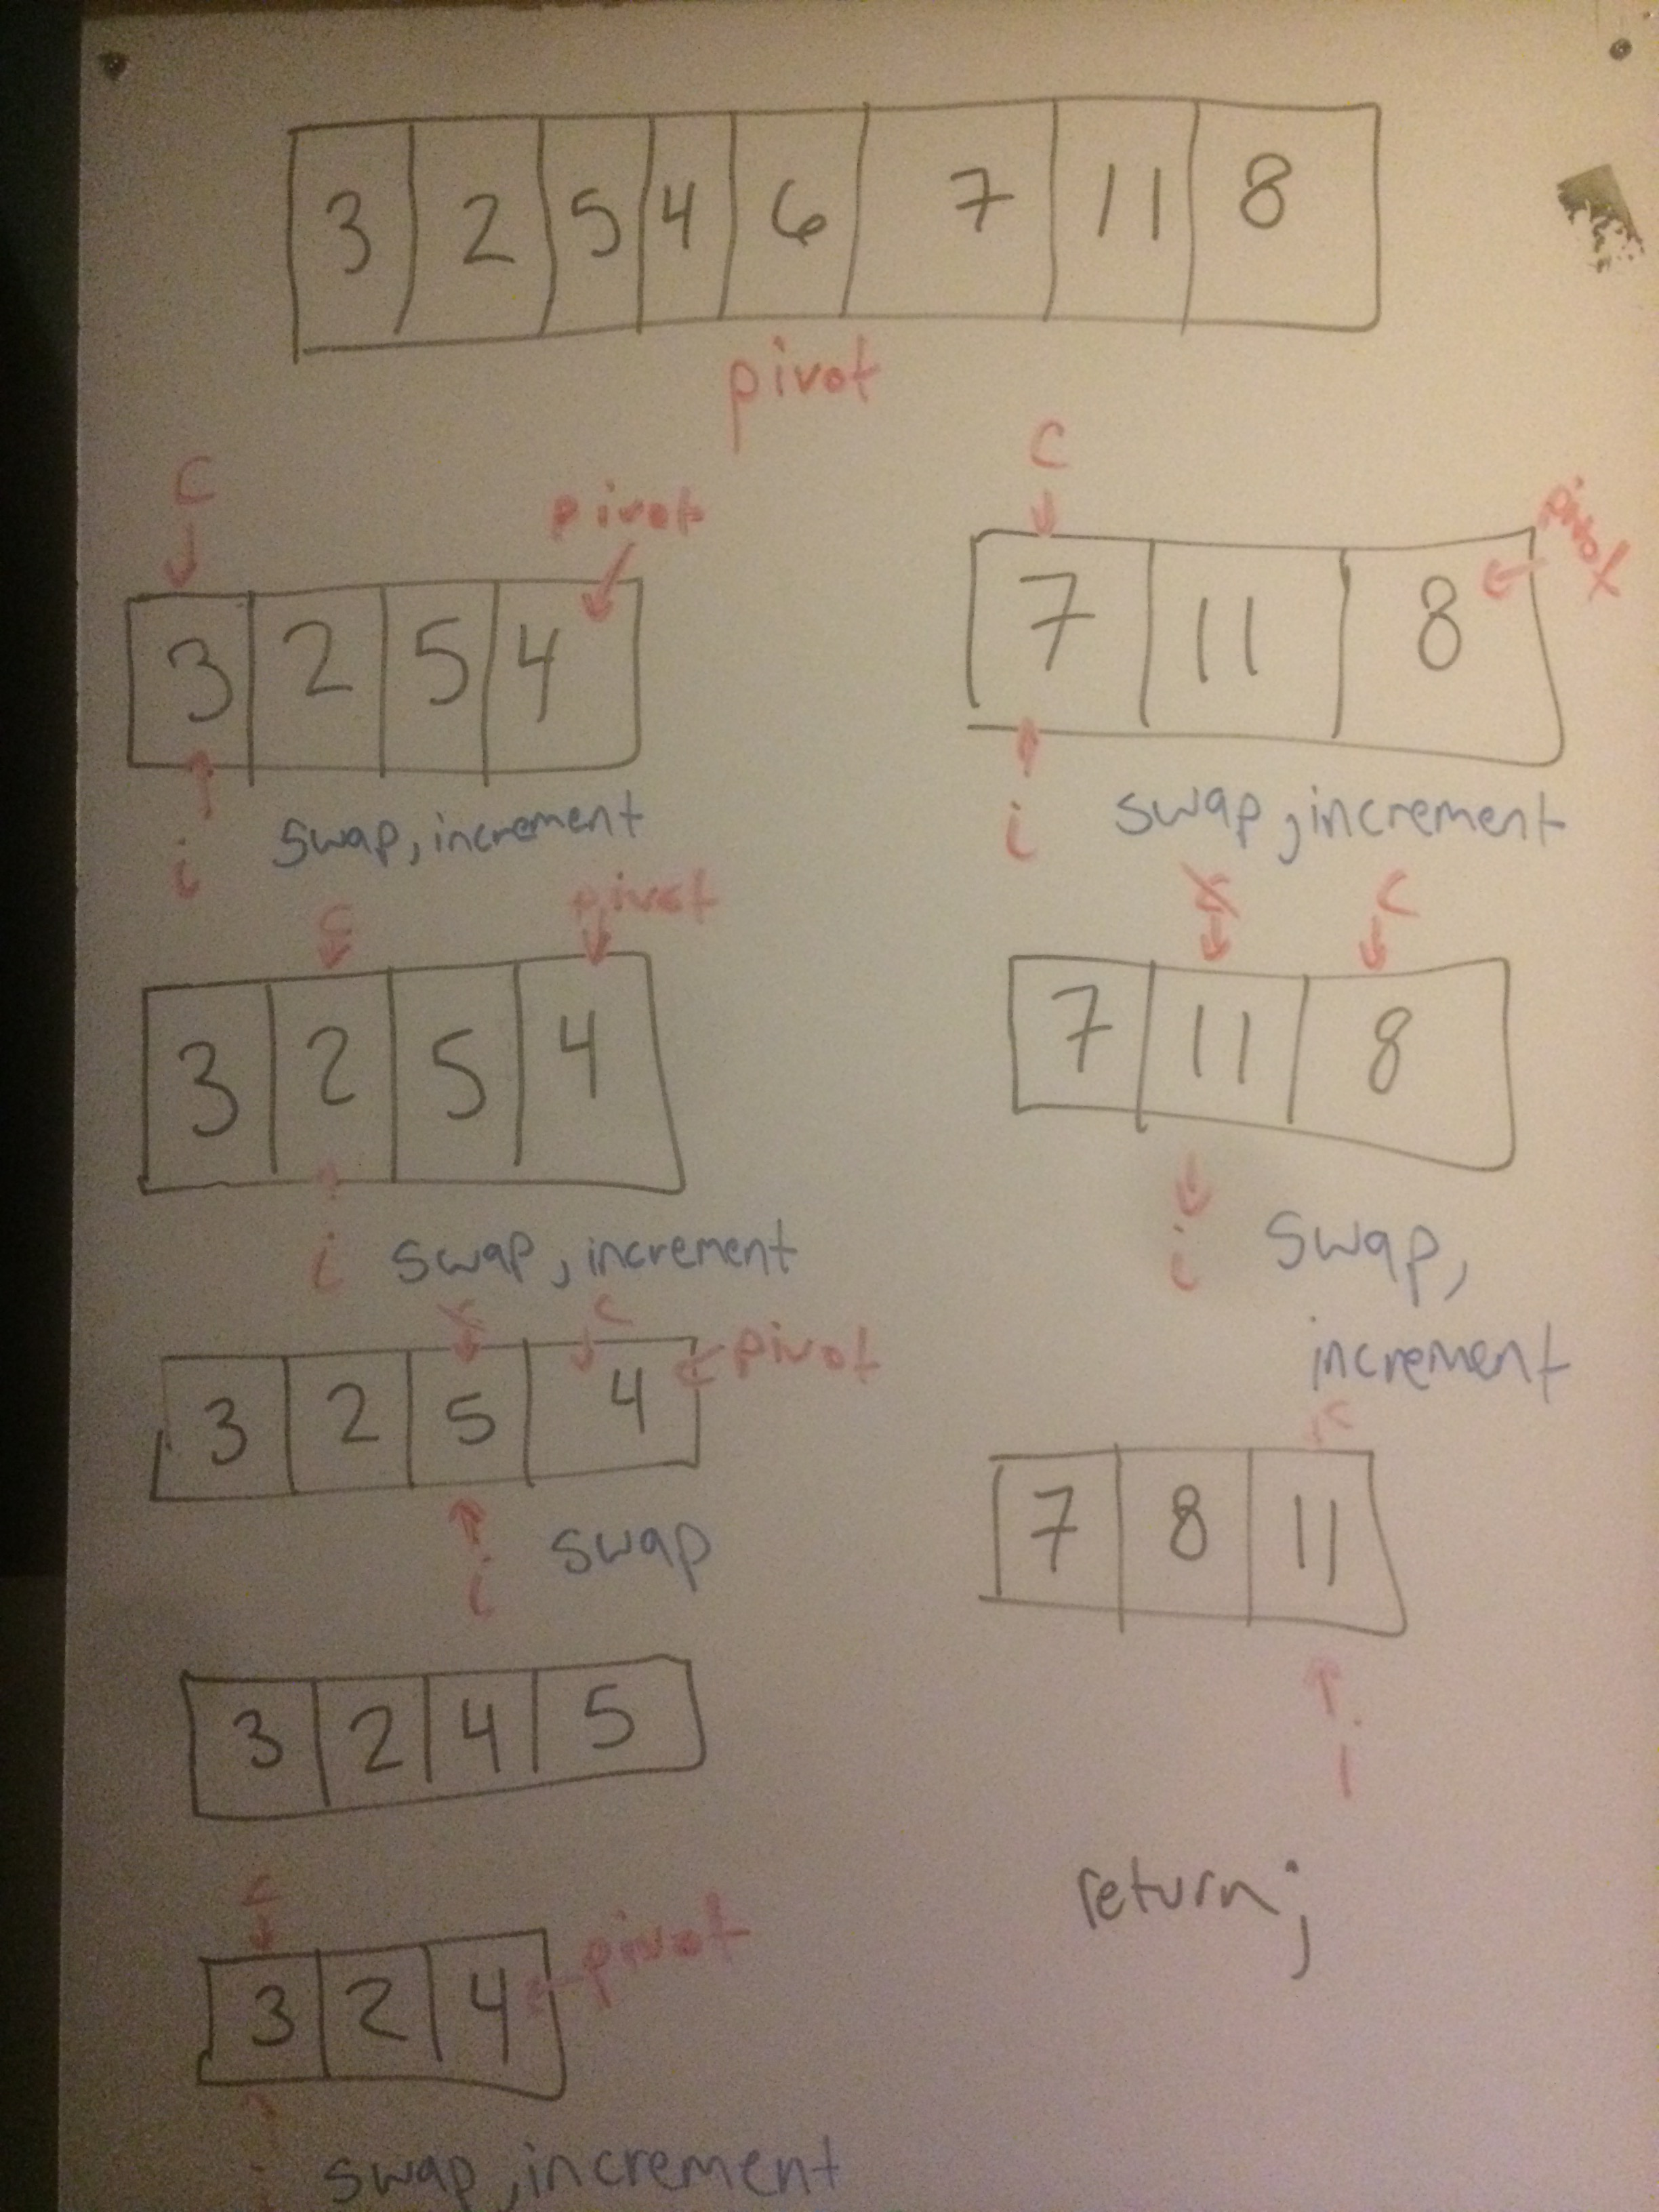

When both sub arrays are returned, it returns a sorted array of A[2,3,4,5,6,7,8,11].

Analyzing the running time of the algorithm quick sort, ‘n’ will be the number of items to be sorted. The total work carried out by the partitions on each level is O(n). Quick sort is drawn to be a fragile algorithm due to the algorithm obtaining a good running time depends on the choice of a good pivot (Khreisat). The ideal case with the pivot in the middle of each subarray, the number of levels is about log2n. This results in a running time of O(n log n) on an average and best-case scenario. If however the pivot is, for example, the first element, it would require extensive recursive calling giving the worst case scenario a running time of O(n^2).

Quicksort rearranges the array such that when the two sub arrays are sorted, the whole array is ordered rather than merge sort which breaks the array into two sub arrays to be sorted and then combine the ordered sub arrays to make the whole ordered array (Khreisat).

**V. Bubble Sort**

Bubble sort goes through multiple passes through the array (Sullivan). On every pass, bubble sort compares adjacent elements in the list, swaps the elements if they are out of order, and on each pass, bubble sort moves the largest (“bubble up”) elements to the end of the array. These passes are repeated several times until the array is eventually sorted into increasing or decreasing order (Sullivan). On the following diagram, the unsorted array is presented on top of the diagram. Bubble sort starts at the first element of the array, 6, and compares the following element, 1. Going through the diagram element 6 is bigger than all of the following elements and eventually reaches the end of the array. The bubble sort algorithm repeats the process the second time to return the algorithm as sorted.

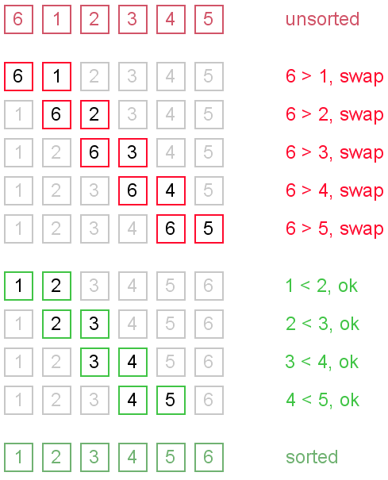

(Algolist.net)

The running time is based on the number of comparisons between elements and the number of exchanges between elements(Sedgewich). On a best case scenario, all of the elements in the array would be sorted already leaving the running time at linear, O(n). On an average-case and worst-case scenario, the running time would be at a maximum of O(n^2). The bubble sort would make “n” passes through the data, and each pass will test “n-1” pairs leaving the running time as:

O(n^2) = (n)*(n-1)

No extra memory needs to be required because the elements are only swapping within the array (Ahmad).

**VI. Bucket Sort**

Bucket Sort uses a key field and keys to sort its records. The individual elements of our array are called the records of our data collection (Lintzmayer). A key is a unique identifying value while a key field is a chosen special field to sort the records according to that key field. Bucket sort works well if the keys are small integers.

Keys should be numbered from [0, n-1], n being the length of the array. Input elements distributed uniformly over some known range, [0, n), so all elements are greater than or equal to 0 but less than n. The pseudocode illustrates the algorithm of bucket sort:

Bucket-Sort(A)

n = length[A]

for i=1 to n

do insert A[i] into list B(floor of nA[i]]

for i=0 to n-1

do sort list i with insertion-sort

Concatenate lists B[0], B[1], …, B[n-1]

The following pseudocode can demonstrate the illustration of bucket sorting the following array:

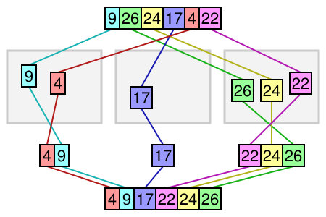

(Growingwiththeweb.com)

array[A] is the colored array on top of the diagram. ‘n’ will equal the length of the array, which will equal to 6. Using a for-loop to iterate through the array, we look at the placeholder of each element. Records 9 and 4 are actually interpreted as 09 and 04. These two get placed in one array, followed by 17 placed in one array due to having 1 as its ten’s decimal number, and 26, 24, and 22 in another array due to their ten’s decimal number as 2. Once the first for-loop iterates placing all the records in their designated array, then the those arrays perform an insertion sort to sort that array to return at array sorted and return all those array into a complete sorted array.

Bucket list is not considered an in-place algorithm. In-place algorithms updates input sequence only through replacements or swapping of elements (Lintzmayer). Bucket sort has a running time of O(n), but more specifically O(n+N). All of the scenarios from worst-case to best-case all result to the same running time, O(n). The time for the array to iterate through each interval takes O(n) time total. The expected number of elements in each bucket is O(1) so total is O(n) and O(n) time to scan the n buckets containing a total of n input elements. Bucket sort does not require extra memory requirements because the array length is known and it is not an in-place algorithm. The algorithm does not use extra space for manipulating the input but may require a small though non-constant extra space for its operations.

**VII. Coding Interview**

**If you have a 20 GB file with one string per line, which sorting algorithm would you use to sort the file and why?**

20 GB’s is too big of a file to sort and we don’t want to bring all 20GB of data into memory. Choosing from the list of mentioned sorting algorithms in this paper, we can’t use Insertion Sort, Bubble Sort, and Quick Sort due to the size of data, which would cause the function to re-iterate through 20 GB of data and would cause our running time to go higher. Bucket Sort would not be ideal because 20 GB of data could possibly obtain more letter characters than the English language. This would cause a huge key field, which would conclude insufficient. Merge Sort would be the correct sorting algorithm to choose from the list. 20 GB of data would be divided into chucks so efficient memory usage would come into play. Once the chunks of data are sorted they will merge and have the 20 GB of data sorted.

**VIII. Comments and Conclusion**

The previous 5 sorting algorithms are only some examples from the mass variety there are to choose from. When the question arises, “What’s the best algorithm to use for sorting”, the key is not just respond to any sorting algorithm. Each sorting algorithm has their strength and weaknesses so it is important to fully understand the context before you can select the best algorithm for a particular situation. When facing this dilemma, it is useful to ask yourself these three questions:

1. What do we know about the data?
2. What are the requirements for the sort?
3. What do we know about the system?

Knowing about the data, is the data already sorted or mostly sorted? How large are the data sets likely to be? Can there be duplicate key values? Knowing the data can distinguish whether to use a bucket sort if the data are low values or merge sort if the data is 10GB of data (Mongan). The requirements for the sort optimize for best-case, worst-case or average-case performance? Does the sort need to be stable? These questions relate to data as to distinguish whether the worst-case scenarios will usually always occur or rarely occur. Knowing about the system can indicate if the largest data set to be sorted smaller than, the same size as, or larger than available memory to follow along the system requirements and capabilities.

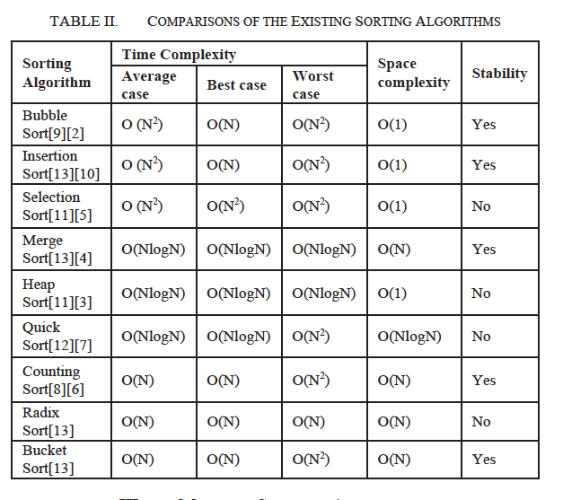

The table below illustrates the importance of asking these questions. The table gives some representative values for comparison.

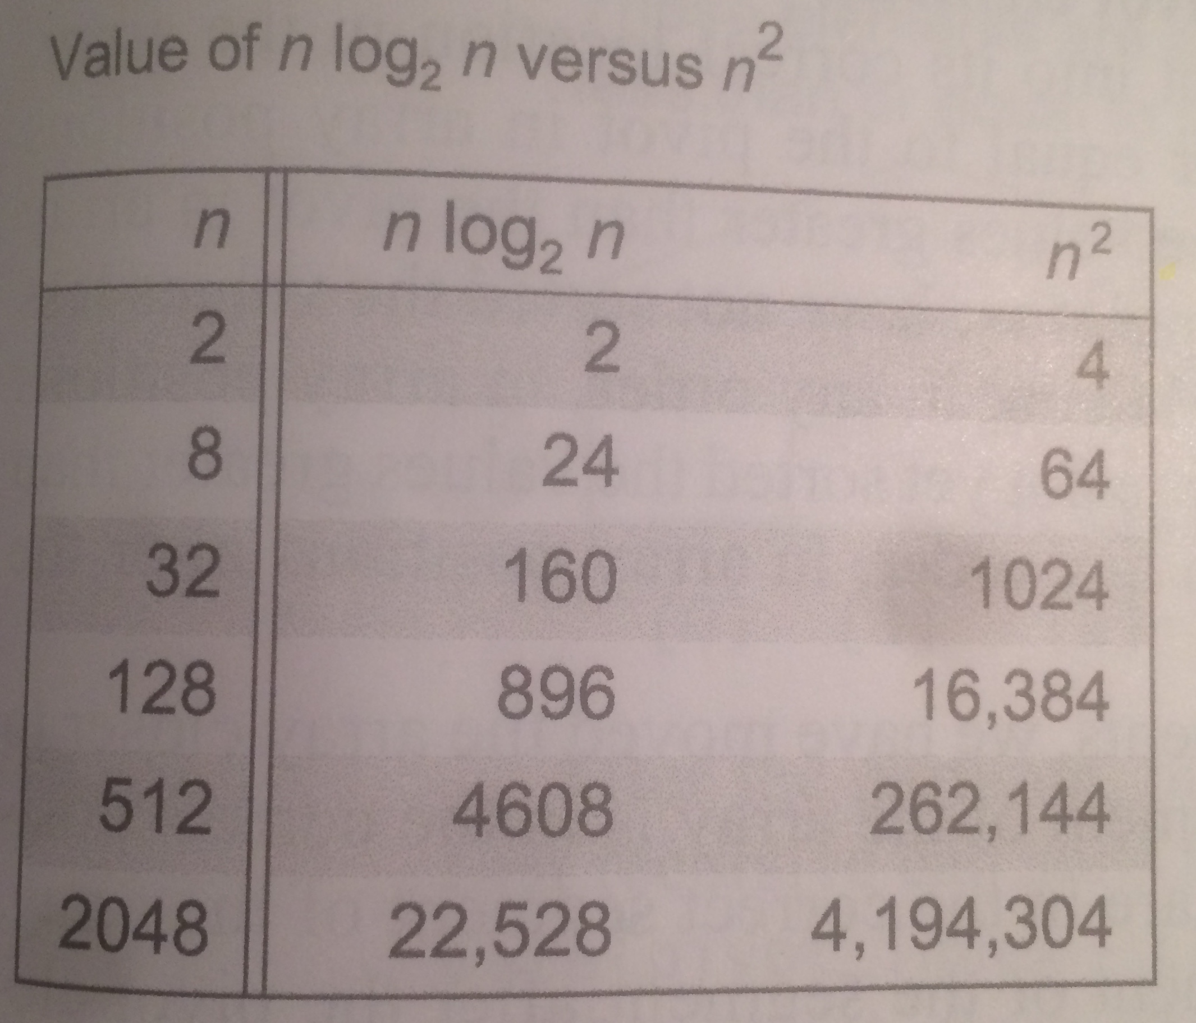

In the table an nlog2n running time is substantially faster than an n^2 running time, especially if the array was to be large and sorted (book).

**IX. List of References**

Ahmad, N. Dayang, N Jawawi, Norhayati. (2013). Bubble Sort. SCJ2013 Data Structure & Algorithms, PPT, <http://ocw.utm.my/file.php/31/Module/ocwChp5BubbleSort.pdf>.

Algolist.net. bubble-Sort-3. <http://www.algolist.net/img/sorts/bubble-sort-3.png>

Growingwiththeweb.com. Bucket-Sort.png. http://www.growingwiththeweb.com/images/2015/06/29/bucket-sort.png

Khreisat, Laila. (2007). QuickSort, A Historical Perspective and Empirical Study. IJCSNS International Journal of Computer Science and Network Security, VOL.7 No.12, December 2007.

Lintzmayer, C. N., Fertin, G., & Dias, Z. (2015). Approximation algorithms for sorting by length-weighted prefix and suffix operations. Theoretical Computer Science, 59326-41. doi:10.1016/j.tcs.2015.05.039

Mapping sorting algorithm. (2016). 2016 SAI Computing Conference (SAI), SAI Computing Conference (SAI), 2016, 488. doi:10.1109/SAI.2016.7556025

Main, M. Savitch, W. (2011). Data Structures and Other Objects Using C++. 4th edition. Boston, MA: Pearson.

McDowell, Gayle Laakmann, 1982-. (2011). Cracking the coding interview : 150 programming questions and solutions. Palo Alto, CA :CareerCup, LLC.

Merge sort enhanced in place sorting algorithm. (2016). 2016 International Conference on Advanced Communication Control and Computing Technologies (ICACCCT), Advanced Communication Control and Computing Technologies (ICACCCT), 2016 International Conference on, 698. doi:10.1109/ICACCCT.2016.7831730

Mongan, J., & Suojanen, N. (2000). Programming interviews exposed: Secrets to landing your next job. New York: Wiley.

Sedgewich, R. Wayne, K. (2011). Algorithms. 4th edition. Boston, MA: Pearson.

Sullivan, D. (2012). Sorting and Algorithm Analysis. Computer Science E-119 Harvard Extension School Fall 2012, pdf, <http://ocw.utm.my/file.php/31/Module/ocwChp5BubbleSort.pdf>